Discussion Summary:
A structured look at OM: Boundary Partners

Discussion on the OM Community Map:

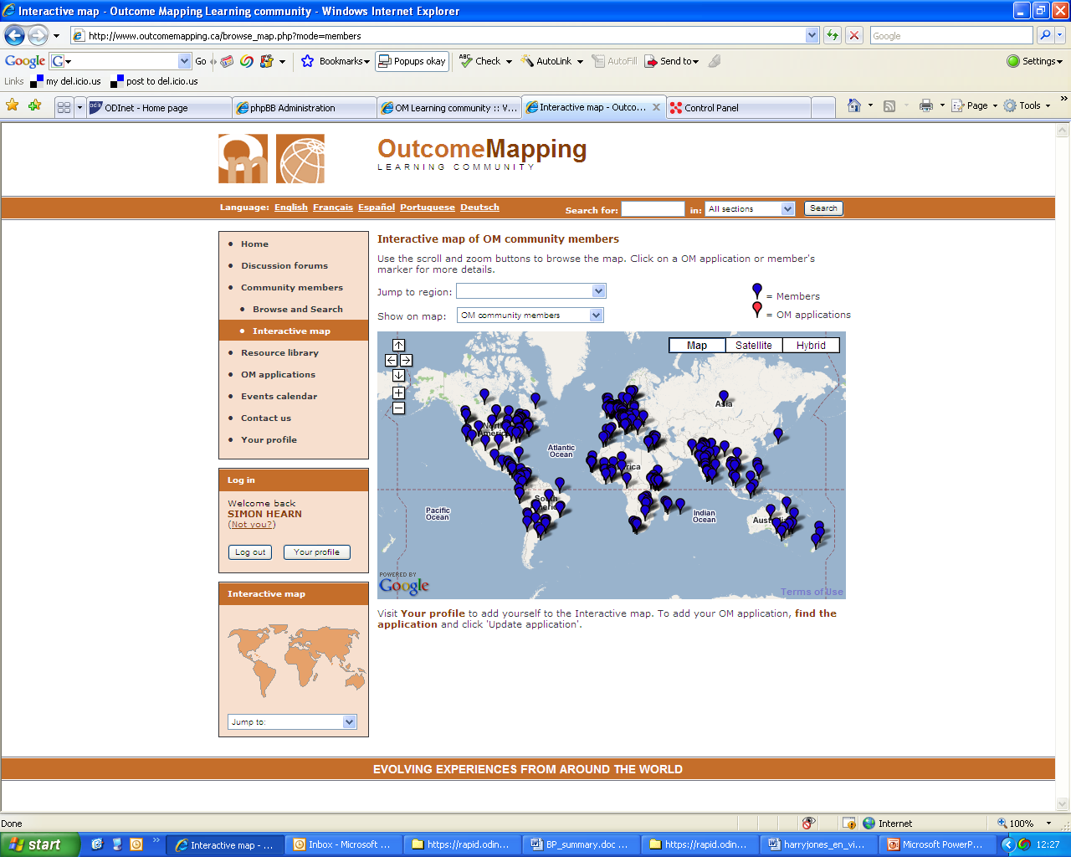



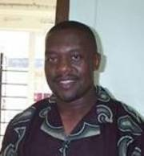



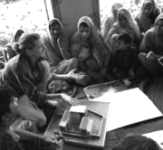
Question: Experiences, tips, questions about the boundary partner element?

Simon Hearn, UK
Reply 1:
The AIIM is a useful tool for stakeholder analysis, to use along side OM.
Enrique Mendizabal, UK
Reply 2:
a. There’s also a 3D version of the AIIM.
b. Should BPs be defined from the organisations perspective rather than the programme?
Rick Davies, UK
Reply 7:
3 things to remember when working with networks.

Ricardo Wilson-Grau, Netherlands
Reply 8:
Adapt your strategy map to think about the BP as part of a wider network as well as an individual and as part of an environment.
Steve Powell, Bosnia and Herzegovina
Reply 6:
Keep in mind who you are trying to influence and who is doing the influencing.
Weeraboon Wisartsakul, Thailand

Reply 9:
What is the best way to group BPs?

Andre Ling, India

Reply 3:
The AIIM will be very useful for us in Zambia.

Friday Mwaba, Zambia

Reply 4:
The OM definition of BPs poses a challenge for researchers.
Julius Nyangaga, Kenya
Reply 5:
See previous discussions on BPs in the recent publication ‘Making Outcome Mapping Work’.
Harry Jones, UK

Prepared by Simon Hearn
15th January 2008

Link to full discussion online: http://www.outcomemapping.ca/forum/viewtopic.php?t=158

Original Email
Simon Hearn, UK
10th October 2007

Dear all,

A while back we started a series of discussions centred around the 12 steps
of OM. We first looked at Vision (Harry Jones produced a summary here:
http://www.outcomemapping.ca/resource/resource.php?id=119), we then looked at
Mission (http://www.outcomemapping.ca/resource/resource.php?id=120).

We're going to kick off the new season with a discussion on step 3 of OM:
Boundary Partners.

The OM Manual says "Boundary partners are those individuals, groups, or
organisations with whom the programme interacts directly and with whom the
programme can anticipate opportunities for influence".

What are your experiences of applying the Boundary Partners element of OM?

Are there any tips for identifying boundary partners, and how to shape your
work around them?

Does anybody have any burning questions about this part of Outcome Mapping?

Regards,

Simon

Responses were received, with many thanks, from:
- Enrique Mendizabal, UK
- Rick Davies, UK
- Friday Mwaba, Zambia
- Julius Nyangaga, Kenya
- Harry Jones, UK
- Simon Hearn, UK
- Weeraboon Wisartsakul, Thailand
- Ricardo Wilson-Grau, Netherlands
- Steve Powell, Bosnia and Herzegovina
- Andre Ling, India

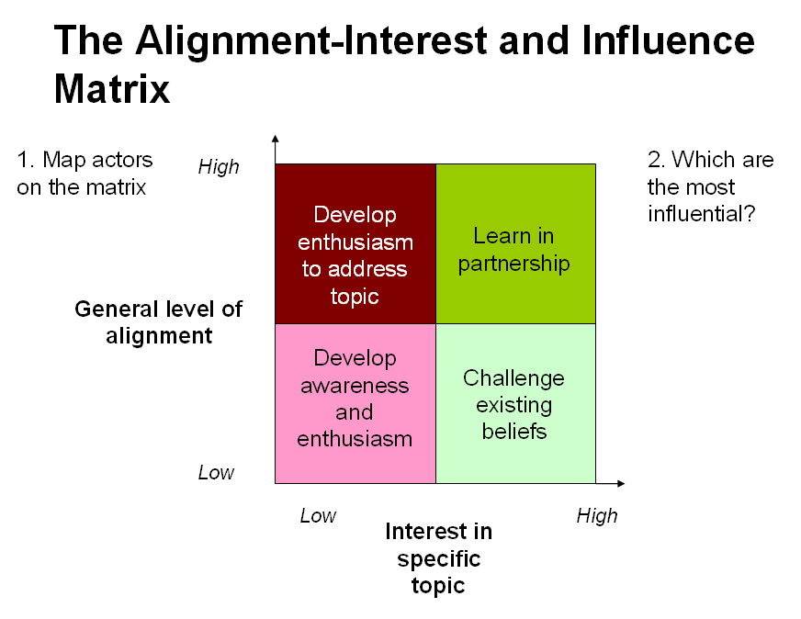
Summary of Responses:

- Enrique Mendizabal offered a simple stakeholder analysis tool used by RAPID, called the AIIM (Alignment, Interest, Influence Matrix). It has been found to be useful for identifying boundary partners and gives an idea of the kind of work that needs to be done and how challenging it could be. For more details about the tool and guidelines on how to use it see the resource uploaded by Enrique: http://www.outcomemapping.ca/resource/resource.php?id=135
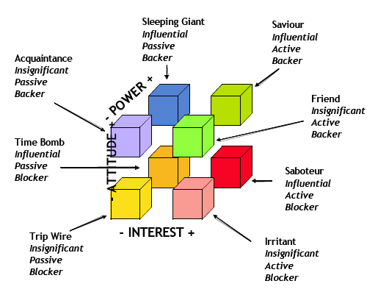
- Rick Davies took this idea further by directing the community at a three dimensional version of the AIIM developed by Ruth Murray-Webster & Peter Simon in their 2006 publication “Making Sense of Stakeholder Mapping”: http://www.pmforum.org/library/tips/2006/PDFs/11-06-Lucidius.pdf.
- Rick also raised the issue that defining boundary partners from the perspective of the programme, as stated in the manual, is a problem since programmes are often very complicated and it is often uncertain as to who is in the programme and who is a BP of the programme. Rick suggested that it would be easier to operationalise if BPs were defined from the perspective of the organisation.
- Friday Mwaba shared his experience of working with partners in Zambia and immediately saw the potential of using the stakeholder analysis tools described above to make the job of partner selection easier.
- Julius Nyangaga contributed to the discussion a short article about BPs from the researcher’s approach (http://www.outcomemapping.ca/resource/resource.php?id=136). His premise for the article is that the researchers work in a different way to development practitioners and that the OM definition of BPs presents a challenge for researchers using the method to plan their projects. Namely,
  - researchers are reluctant to engage with other actors during the design phase;
  - researchers often fail to see the value in measuring behaviour change of BPs and look straight to changes in beneficiaries.
In the article, Julius shares his experience working with research teams applying OM and some possible ways of understanding and applying the concept of boundary partners.
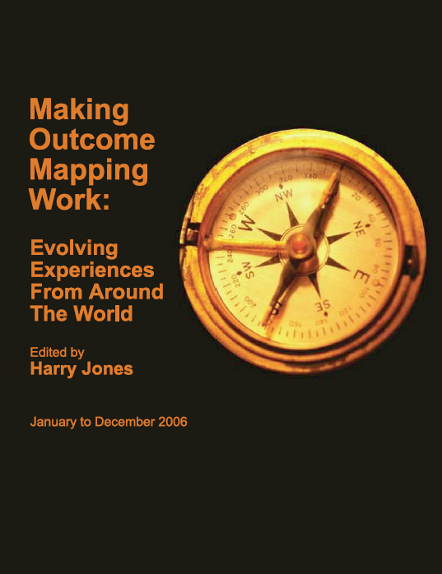
- Harry Jones linked back to previous discussions on this forum and quoted from the recent publication ‘Making Outcome Mapping Work', a collection of discussion summaries from the first year of the Outcome Mapping Learning Community (http://www.outcomemapping.ca/resource/resource.php?id=139). The discussions were about the importance of BPs as a concept in OM and some concerns about whether this concept constrains the way the project/programme works.
- Simon Hearn responded to Rick Davies comment on perspective and on defining whether a particular actor is a BP or part of the programme. He gave a couple of recent examples where this problem has posed a challenge and asked for experience and advice from other members.
- Weeraboon Wisartsakul shared a few ideas about how the Thai Health Promotion Foundation dealt with this challenge. They focussed on whose behaviour needs changing and who has the influence to change it. In some cases Thai Health are influencing their grantees to change, in which case they would be an internal BP. But not all grantees are BPs. In other cases grantees, together with Thai Health, are influencing other people or organisations to change; these would be external BPs.
- Ricardo Wilson-Grau made three recommendations from his experience working with international social change networks:
  - it is wise to constantly re-assess the boundary where control ceases and influence begins;
  - internal or organic outcomes are a necessary complement to changes in external social actors;
  - intense monitoring of boundary partners and the changes in their behaviour, relationships and actions is more important than planning or evaluation.
- Steve Powell added an alternative approach dealing with the challenge of networks as BPs which arose from work in Bosnia and Herzegovina and treats BPs as individuals and systems at the same time while planning strategies for both. The idea is to add a third row in the strategy maps table called system or group placed between the individual and environment rows.
- Ricardo agreed that the distinction between groups and individuals is helpful to think about in network situations because you often want to influence the network staff or representatives as well as the network members. But he didn’t find it helpful to think about systems as BPs in this context because systemic changes are usually changes in state or environment and OM isn’t concerned with measuring these.
- Steve agreed with these points and suggested sticking with the groups title. He also suggested, as an alternative to the adaptation of the strategy maps, that the individuals and the groups can be treated as separate BPs.
- Andre Ling wanted further clarification on this adaptation of the strategy maps. He questioned the addition of the group row, suggesting that an organisation row would also be needed for completeness. He also offered some advice about thinking in terms of system. Firstly, that it’s useful for seeing the big picture of how the ‘totality of everything contained in the OM framework’ is functioning. Secondly, that the complexity of reality is not lost when systems are used to create ‘models’.
- Andre also had a question about applying the BP element of OM in a community development project in India that he is involved in. He wanted advice about how to group BPs and whether a sub-group ('particularly active citizen leaders') should be treated as separate BPs.

Concluding remarks and actions to take forward:
- The concept of boundary partners is one of the ways in which Outcome Mapping really sets itself apart from other approaches. It forces you to recognise the limits of your influence and to think realistically about whom you wan work with to affect change.
- The crucial thing to remember with Outcome Mapping is perspective. When identifying boundary partners, you have to put yourself in the picture at a specific point and define BPs from that point.
- Outcome Mapping is robust and flexible enough to allow it to be adapted and applied to a wide range of contexts. The boundary partner element often needs careful thought at the beginning of the project to ensure it works in the specific context - e.g. researchers, networks.
- It can often be beneficial to undertake a comprehensive stakeholder analysis to complement the boundary partner step. There are additional tools to aid this process.
- The question of how best to group boundary partners has yet to be answered.

